Bio

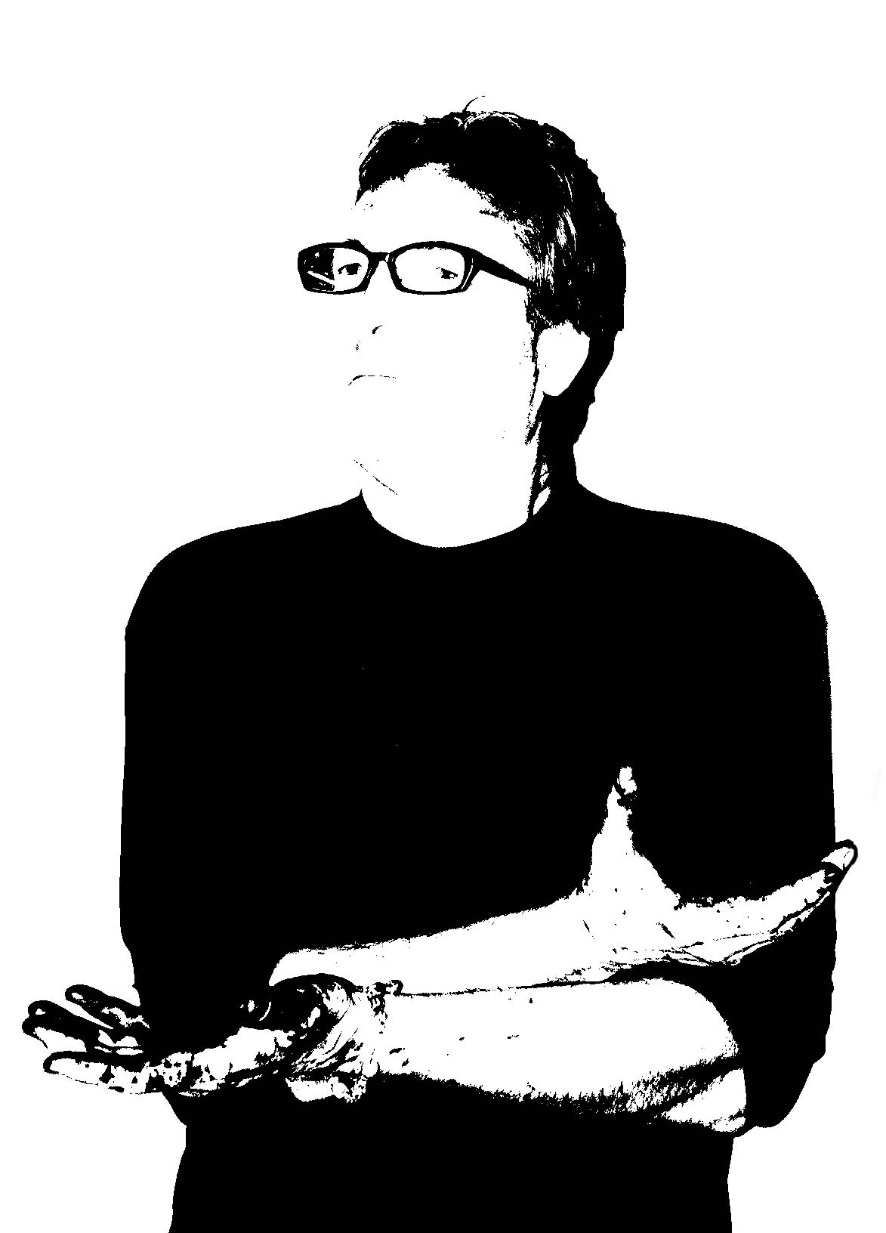

Jeff Zischke
artist and designer.

Jeff’s work is collected globally and includes multi-media works and public sculpture.
He recently completed an artist residency in Belgrade, Serbia creating temporary sculpture and monoprints at the University in Sremski Karlovci.

His work incorporates organic imagery developed into temporal and permanent artworks that explore the creative process in a myriad of new and different ways. The recent H U M I Project was developed several months ago while exhibiting in Japan.

Selected collections include: The City of Nicosia, Cyprus, Eco-Musee ; Puget-Rostang France, HAC Gallery: Kobe Japan, The City of Detroit, Michigan, SRP Headquarters, Phoenix, AZ . and the cities of Scottsdale, and Tempe, Arizona . He has designed and built light fixtures and cabanas for the W Hotel in Scottsdale, Arizona and has designed several restaurants and nightclubs in Arizona and Colorado. Mr Zischke’s design work has been displayed at the Salon Del Mobile in Milan, Italy and Designers Block, London , England.

